**Project Proposal**

**OOSE**

**Submitted To:** Sir Mukhtiar Zamin

**Submitted By:** Shiza Kabir

(SP20-BSE-081)

Rameen Naeem

(SP20-BSE-057)

Date: 3-10-21

**Project Title:**

**Personal Safety App**

**(Stay Safe)**

**Introduction:**

The same widely spread internet network can be utilized to help out people in need of emergency. This application proposed here aims at raising alerts & send message with location if anyone is facing any emergency in the form of any threat from someone, health emergency, accidental emergency.

Safety for people is one of the most pressing issues of our time that should have been a fundamental, undeniable concept for any civilized society centuries ago. The need for a safety app is, unfortunately, increasing in the current societies across the world. One of the biggest roles that have been played in ensuring the safety of people, has to be the digital transformation and advancement in technology. Especially in the world where 3 out of every 5 people have smartphones and use dozens of mobile apps every day.

Our Application helps user in case of any emergency or mishap by sending an emergency alert to their closed ones and nearest police station. Users of Safety app can send threat alerts to the contacts added and selected police stations with the location in the app.

This is user-friendly application that can be accessed by anyone who has installed it in their smart phones. Our intention is to provide you with fastest and simplest way to contact your nearest help.

* The user can add his important contacts in the system whom he wants to inform in case of emergency.
* The user can select nearest in the system whom he wants to inform in case of emergency.
* The user can send alerts through this application in the form message with location indicating an emergency.

In this way, this safety application can help a group of people stay connected & help each other in case of any emergency in the least time possible.

**Vision and business Case:**

**High Level Goals:**

|  |  |  |  |
| --- | --- | --- | --- |
| **High Level Goals** | **Priority** | **Problem And Concerns** | **Current Solutions** |
| Fast, secure,  User friendly | High | Calling or texting simply from mobile phone in a panic situation takes more time. | Option of an emergency call is given in the mobile phones but it takes time to call and impossible to send the location URL. |

**Executive Summary:**

In today’s world, people using smart phones have increased rapidly and hence, a smart phone can be used efficiently for personal security or various other protection purposes. Our Application for the Safety of people and this app can be activated this by a single click, whenever need arises. A single click on this app identifies the location of place through GPS and sends a message comprising the location URL to the added contacts to help the one in emergency situations.

Our application has the following main features;

* **Registration:**

When user will install the app for the first time he/she needs to register their phone number once.

* **Confirmation:**

After registration a 4-digit verification code will be sent to the registered number of the user. User will enter the code, if code matches, registration will be done otherwise will ask again for the code.

* **Main menu:**

In this section user will have following option,

* Instructions
* Set Profile
* Enable Location
* Invoke Emergency
* Add police Station
* Modify Police Station
* **Emergency button:**

Once the app is activated, the user will have an emergency message with the emergency button whenever he/she opens the app.

This project is an application where we have to install in the mobile and register the number once, if we find some dangerous signs at any time we have to just open the application in our mobile and an emergency button will appear. By clicking on send message button an emergency message will be sent to the added contacts with the location.

**Functional Requirements:**

* System must send a verification code to user for registering the number.
* System must ask the user to turn on the GPS location.
* System must send an emergency message to the added contacts and Police Station as soon as emergency button is clicked.
* System must provide the facility of adding or deleting any contact from contact list

**Supplementary Specification**

**Non-Functional Requirements:**

**Responsiveness:-**

Application should be responsive to the user Input or to any external interrupt which is of highest priority and return back to same state

**Performance:-**

The performance of the Application can be determined by it responsive time, time to complete the given task.

**Scalability:-**

App should able to adopt itself to increased usage or able to handle more data as time progress.

**Usability:-**

User should be able to understand the flow of App easily i.e. users should able to use App without any guideline or help from experts/manuals. Our Safety app is a user-friendly app.

**Reliability:-**

The application should be reliable to perform the business, i.e. when user perform some important action it should be acknowledged with confirmation.

**Security:-**

All the app data should be secured and be encrypted with minimum needs so that it’s protected from outside environment also from internal attack.

**Availability:-**

There should be a common plane where the user can access your application to install and look for regular updates give feedback

For example: - Googles Play Store

**Glossary:**

|  |  |  |  |  |
| --- | --- | --- | --- | --- |
| **Term** | **Definition** | **Format** | **Validation Rules** | **Aliases** |
| Number Registration | User will enter the number to register himself once he/she installs the app. |  |  |  |
| Number verification | When user enters the number the system will send the OTP code for the verification of the number. |  |  |  |
| Main menu | Main menu will provide user different options in which user can add, delete or view contacts. |  |  |  |
| Emergency button | A button to send an emergency message. |  |  |  |
| OTP | A verification code which user will receive after entering the number for registration. | 4-digit code. | 4th digit is a check digit. | One-Time Password |
| GPS | For location tracking |  |  | Global positioning system. |

**Risk List and Risk Management Plan:**

|  |  |
| --- | --- |
| **Risks** | **Management Plan** |
| Verification fails | If the entered verification code do not matches with the code sent by the system, system will display a message (“Verification failed enter code again”). |
|  |  |

**Prototype:**

1. **Registration Section**

**\*Login Page**

1. **Number Verification**
2. **Main menu**

**\*Instruction**

**\*Add Monitors**

**\*Monitors List**

**\*Add Police Stations:**

**\*View Police Stations:**

**\*Add City:**

**\*Feedback**

**\*Emergency button**

**Use Case Diagram:**

**Fully dressed Use case of Login**

|  |  |
| --- | --- |
| **Use case:** | Login |
| **Primary Actor:** | User |
| **Scope:** | Personal Safety App |
| **Level :** |  |
| **Stakeholders:** | User: user wants a fast and secure system which can help him in the case of any emergency. |
| **Preconditions:** | User must be registered the app. |
| **Success Guarantee:** | User is logged in the system. |
| **Special Requirements:** |  |
| **Main Success Scenario:** | |
| **Actor Action:** | **System Response:** |
| The user clicks the login button: | The system asks the user to login the system by entering his/her phone number, username, email & password. |
| The user enters his/her username & password: | The system will login the user in his/her account. |
| **Alternative Flow:**  If user enters invalid username or password an error will be generated by the system. The system will ask the user to check and login again. | |

**Fully dressed Use case of Set Profile:**

|  |  |
| --- | --- |
| **Use case:** | Set profile |
| **Primary Actor:** | User |
| **Scope:** | Personal Safety App |
| **Level :** |  |
| **Stakeholders:** | User: user wants a fast and secure system which can help him in the case of any emergency. |
| **Preconditions:** | User must be logged in the app. |
| **Success Guarantee:** | User’s profile will be updated in the system. |
| **Special Requirements:** | Contacts, members, location. |
| **Main Success Scenario:** | |
| **Actor Action:** | **System Response:** |
| The user clicks the set profile button: | The system asks the user to enter his/her contacts and city. |
| The user clicks on save button: | The system will save the profile info of the user. |
| **Alternative Flow:**  If user don’t save the info, the info will be discarded. | |

**Fully dressed Use case of Invoke Emergency**

|  |  |
| --- | --- |
| **Use case:** | Invoke Emergency |
| **Primary Actor:** | User |
| **Scope:** | Personal Safety App |
| **Level :** |  |
| **Stakeholders:** | User: user wants a fast and secure system which can help him in the case of any emergency. |
| **Preconditions:** | 1. User must be logged in the system. 2. User must have enabled the location and have selected the nearest police station. 3. User must have added at least 2 contacts in the system. |
| **Success Guarantee:** | Emergency message sent successfully. |
| **Special Requirements:** | Location must be enabled. |
| **Main Success Scenario:** | |
| **Actor Action:** | **System Response:** |
| The user press the emergency button: | The system will send an emergency alert to the contacts added by the user with location URL. |
| **Alternative Flow:**  If location is not enabled the user won’t be able to press the emergency button. System will ask the user to enable the location first to send an emergency message. | |

**Fully dressed Use case of Give Feedback**

|  |  |
| --- | --- |
| **Use case:** | Give Feedback |
| **Primary Actor:** | User |
| **Scope:** | Personal Safety App |
| **Level:** |  |
| **Stakeholders:** | User: user wants a fast and secure system which can help him in the case of any emergency. |
| **Preconditions:** | User must have Installed the app. |
| **Post Condition:** | None. |
| **Main Success Scenario:** | |
| **Actor Action:** | **System Response:** |
| The user clicks on feedback button: | The system will ask the user to write the remarks for the app. |
| The user gives feedback: |  |
| The user submits the feedback: | The system saves the user feedback. |
| **Alternative Flow:**  None | |

**Brief Level Use Cases:**

**Login:**

This use case starts after installing and registering in the application, as a user opens the app a login page will be displayed to him by the system where he has to enter his username and password to login the system. The use case ends.

**Set Profile:**

This use case begins when user login the system and needs to enter the information i.e. name and number of the monitor and his city to send an emergency alert in any emergency situation to the contacts he wants to. After adding the required info in his profile, he will save the information. The use case ends.

**Invoke Emergency:**

This use case begins when user is already registered and logged in the system and has enabled his/her tracking. Whenever the user is in an emergency, he/she simply opens the app, this use case appears as an emergency button with the option of selecting the nearest police station and sending alert to his contacts and police station. The emergency message will be sent by the system with the location URL of user. The use case ends.

**Give Feedback:**

This use case starts when the user wants to give any kind of feedback about the app. User will simply goes to the menu section there, he will find an option of give feedback by clicking the system will take user to the blank page where user can write suggestions and remarks about the app. The use case ends.

**Domain Model:**

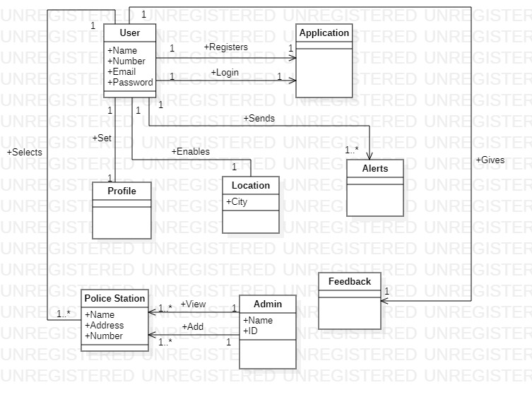

**SSD’s:**

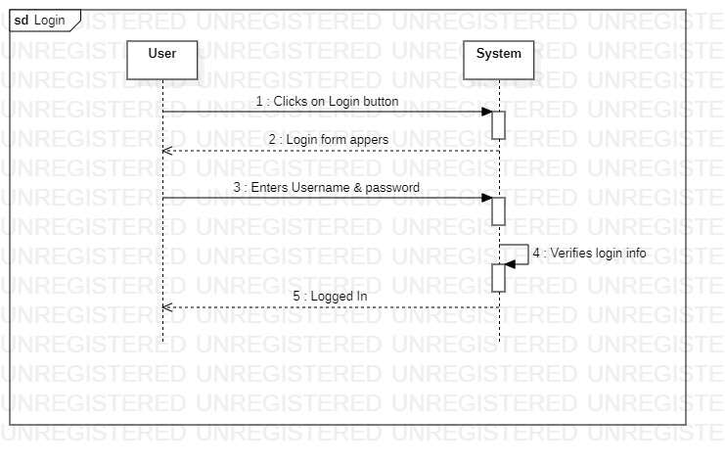

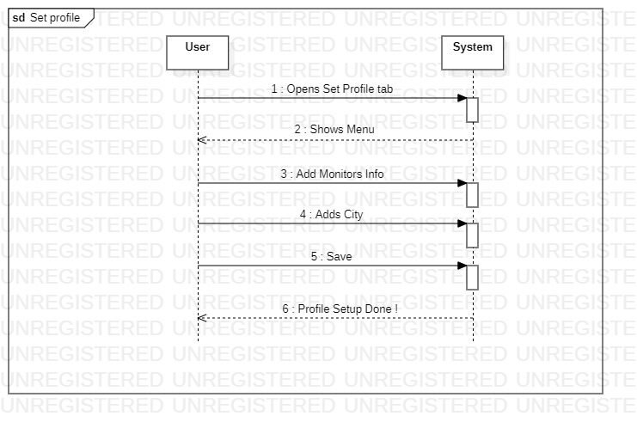

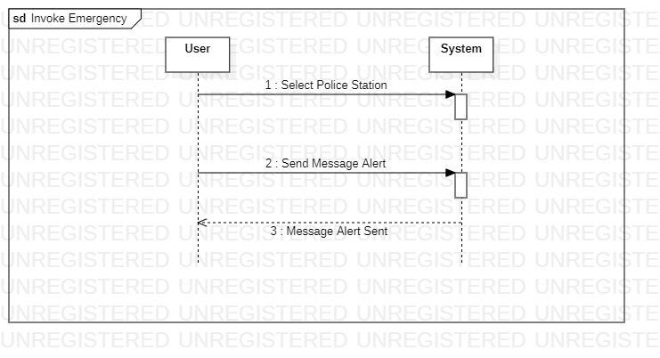

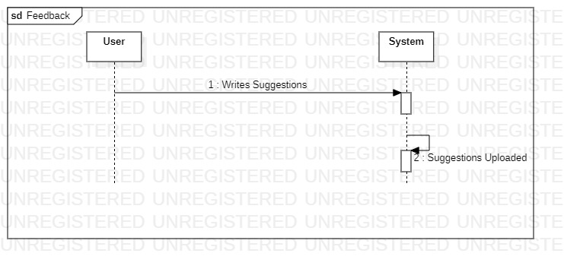

**Operation Contracts:**

|  |  |
| --- | --- |
| **Operation:** | login |
| **Cross reference:** | Use case: Login |
| **Pre-condition:** | User is registered and authenticated in the system |
| **Post-condition** | User logged in the system |

|  |  |
| --- | --- |
| **Operation:** | Add City |
| **Cross reference:** | Use case: Set Profile |
| **Pre-condition:** | User is logged in the system |
| **Post-condition** | City was added and saved. |

|  |  |
| --- | --- |
| **Operation:** | Add Monitors |
| **Cross reference:** | Use case: Set Profile |
| **Pre-condition:** | User is logged in the system |
| **Post-condition** | Monitors was added in the profile. |

|  |  |
| --- | --- |
| **Operation:** | View Monitors |
| **Cross reference:** | Use case: Set Profile |
| **Pre-condition:** | User is logged in the system |
| **Post-condition** | Monitors list was displayed |

|  |  |
| --- | --- |
| **Operation:** | Send Alert |
| **Cross reference:** | Use case: Invoke Emergency |
| **Pre-condition:** | User is logged in the system |
| **Post-condition** | Emergency message was sent by the system. |

|  |  |
| --- | --- |
| **Operation:** | Select Police Station |
| **Cross reference:** | Use case: Invoke Emergency |
| **Pre-condition:** | User is logged in the system |
| **Post-condition** | Police station was added and emergency message was sent. |

|  |  |
| --- | --- |
| **Operation:** | Give Feedback |
| **Cross reference:** | Use case: Invoke Emergency |
| **Pre-condition:** | User is logged in the system |
| **Post-condition** | Feedback was published. |